Traffic Control System in the Connected Cars Context

Route Request by user

Authors: Andrei Tudorica(andreitudoricacj@gmail.com)
Document Number: UC02
Version: 0.0.4

Record of Processing
No. | Version | Date | Status | Who | Description
4 | 0.0.1 | 2019-05-15 | Done.
5
6
7

Record of Approval
No. | Version | Date | Who | Description
1 | … | … | …
2
3
4
5
6
7

Recipients of Document
No. | Version | Date of Distribution | Recipients
1 | … | …
2
3
4
5
6
7
Table of Contents
1 Allocate Resources 5
1.1 Brief Description 5
1.2 Primary Actor 5
1.3 Stakeholders and Interests 5
1.4 References

. 5
2 Flow of Events 6
2.1 Basic Flow 7

3 Special Requirements 8
4 Preconditions 8

5 Postconditions 8

6 Extension Points

8
7 Technology and Data Variation List 8
8 Open Questions 9

Allocate Resources

- Allocate Resources
  - Brief Description
The purpose of this document is to capture the flow of events that occur when a Traffic Participant requests for a route
  - Primary Actor
Traffic Participant.
  - Stakeholders and Interests
Traffic Participant – interested in receiving a route as fast as possible from a start location to a destination.
  - References

Glossary Andrei Tudorica

- Flow of Events

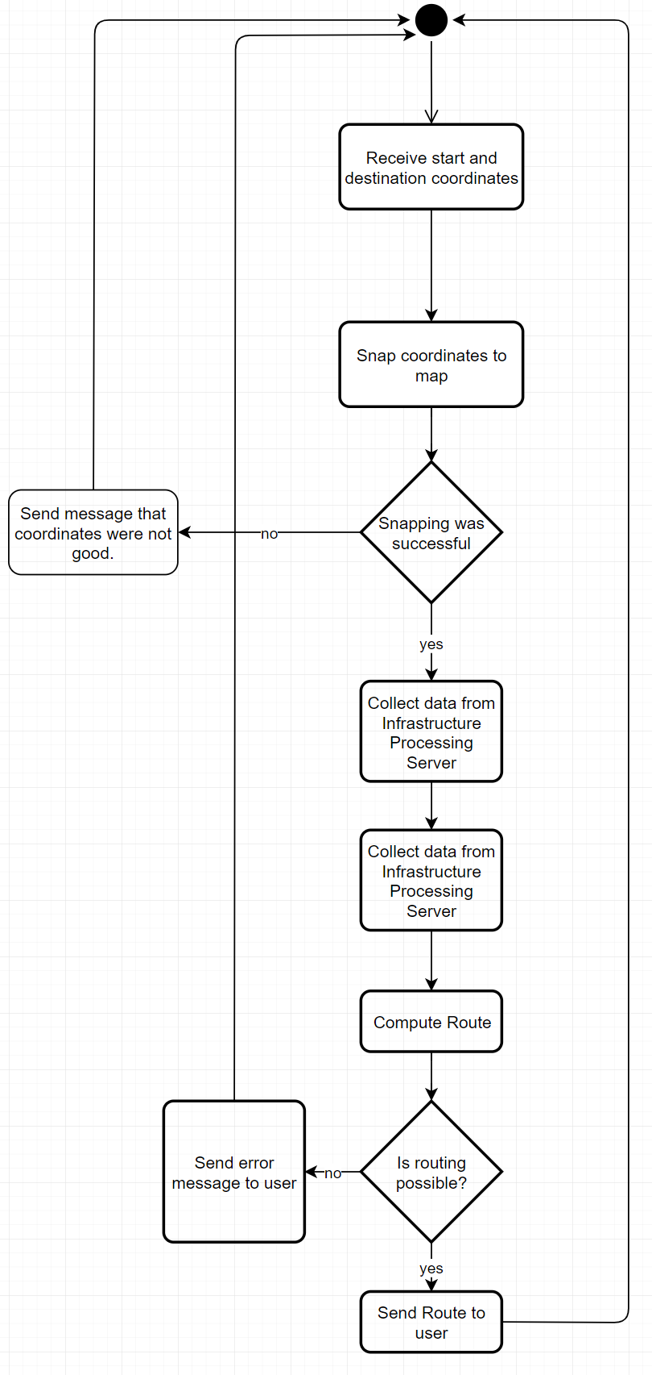

  - Basic Flow

Use-Case Start
This use case starts when the actor requests a route.

The actor sends coordinates for start and destination.

The server succeeds to snap the coordinates to actual road segments.

The server collects data from the infrastructure.

The server collects the statistics from the collected data.

The server computes the requested route.

Use-Case End
The server sends the route to the actor.

  - Alternate flow

Use-Case Start
This use case starts when the actor requests a route.

The actor sends coordinates for start and destination.

The server fails to snap the coordinates to actual road segments.

Use-Case End
- The server sends an error message to the actor

- Special Requirements
Not applicable.
- Preconditions
  - The actor

  - has access to the internet.

  - The actor Has the client application.

- Postconditions

The actor receives a route.

- Extension Points

Add more weight computing options.
- Technology and Data Variation List
The infrastructure and collected data might or might not be used.
- Open Questions
Not applicable.

